FDM BASED 3D PRINTER

Author and Co-Authors Name: Name Surname1, Name Surname2 <14 point>

12Affiliation

12Panimalar Engineering College, Chennai, India

*Abstract:* Fused Deposition Modeling (FDM) is a layer additive manufacturing (or 3D Printing) process that uses production-grade thermoplastic materials to produce both prototype and end-use parts. Solid Concepts offers a number of thermoplastic FDM materials that can be used for direct digital manufacturing including ABS, PC-ISO polycarbonate and Ultem-9085 for high-temperature applications. Since FDM parts are constructed with production-grade thermoplastics, they are functional and durable. In fact, Ultem-9085 is flame, smoke and toxicity certified to UL-94V0 and FAA 25.853 standards and possesses an excellent strength-to-weight ratio.

***Keyword:* Fused Deposition Modelling (FDM), additive manufacturing, 3D Printing, Thermoplastic.**

**I. INTRODUCTION TO FDM**

FDM begins with a software process which processes an STL file (stereolithography file format), mathematically slicing and orienting the model for the build process. If required, support structures may be generated. The machine may dispense multiple materials to achieve different goals: For example, one may use one material to build up the model and use another as a soluble support structure, or one could use multiple colours of the same type of thermoplastic on the same model. The model or part is produced by extruding small beads of molten material to form layers as the material hardens immediately after extrusion from the nozzle. A plastic filament or wire is unwound from a coil and supplies material to an extrusion nozzle which can turn the flow on and off. There is typically a worm-drive that pushes the filament into the nozzle at a controlled rate. The nozzle is heated to melt the material. The thermoplastics are heated past their glass transition temperature and are then deposited by an extrusion head. The nozzle can be moved in both horizontal and vertical directions by a numerically controlled mechanism. The nozzle follows a tool-path controlled by a computer-aided manufacturing (CAM) software package, and the part is built from the bottom up, one layer at a time. Stepper motors or servo motors are typically employed to move the extrusion head. The mechanism used is often an X-Y-Z rectilinear design.

**II. 3D PRINTER MANUFACTURERS.**

1. ***Market Competitors.***

Several projects and companies are making efforts to develop affordable 3D printers for home desktop use. Much of this work has been driven by and targeted at DIY/enthusiast/early adopter communities, with additional ties to the academic and hacker communities. RepRap is one of the longest running projects in the desktop category. The RepRap project aims to produce a free and open source hardware (FOSH) 3D printer, whose full specifications are released under the GNU General Public License, and which is capable of replicating itself by printing many of its own (plastic) parts to create more machines. RepRaps have already been shown to be able to print circuit boards and metal parts. Fab@Home is the other opensource hardware project for DIY 3D printers.

***B. Comparison.***

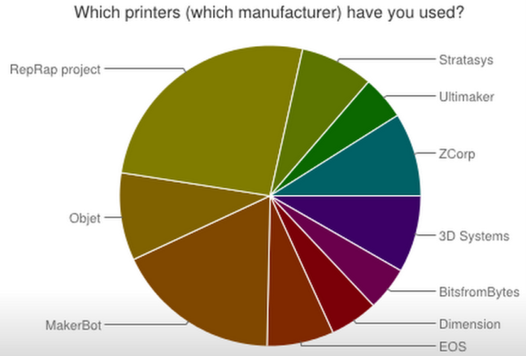

RepRap is humanity's first general-purpose self-replicating manufacturing machine.

RepRap takes the form of a free desktop 3D printer capable of printing plastic objects. Since many parts of RepRap are made from plastic and RepRap prints those parts, RepRap self-replicates by making a kit of itself - a kit that anyone can assemble given time and materials. It also means that - if you've got a RepRap - you can print lots of useful stuff, and you can print another RepRap for a friend.

RepRap is about making self-replicating machines, and making them freely available for the benefit of everyone. We are using 3D printing to do this, but if you have other technologies that can copy themselves and that can be made freely available to all, then this is the place for you too.

Reprap.org is a community project, which means you are welcome to edit most pages on this site, or better yet, create new pages of your own. Our community portal and New Development pages have more information on how to get involved. Use the links below and on the left to explore the site contents. You'll find some content translated into other languages.

RepRap was the first of the low-cost 3D printers, and the RepRap Project started the open-source 3D printer revolution. It has become the most widely-used 3D printer among the global members of the Maker Community.

***C. MODIFIED PRUSA I3***

The Prusa i3 (iteration 3) is the newest and most current 3D Printer design by RepRap Core Developer Prusajr. The i3 incorporates lessons learned from the previous two Prusa designs, as well as other popular modern RepRap designs. The Modified Prusa i3 is fully made of rigid construction by using Metals like aluminium and Mild Steel.

***A. Specification.***

|  |  |
| --- | --- |
| Plastic Parts (exc. Extruder) | 26 |
| Non Printed Parts approx. | 337 |
| Cost | 30,000-60,000 INR |
| Controller Electronics | Ramps |
| Printing Size | 200 x 200 x 200 |
| Motors | 5 x NEMA 17 Stepper |
| Frame Material | 6mm Aluminium, Wood |
| Frame Manufacture | Laser Cutter, CNC, Water Jet |
| Pro | Easy assembly |
| Con | Specialised Tools |

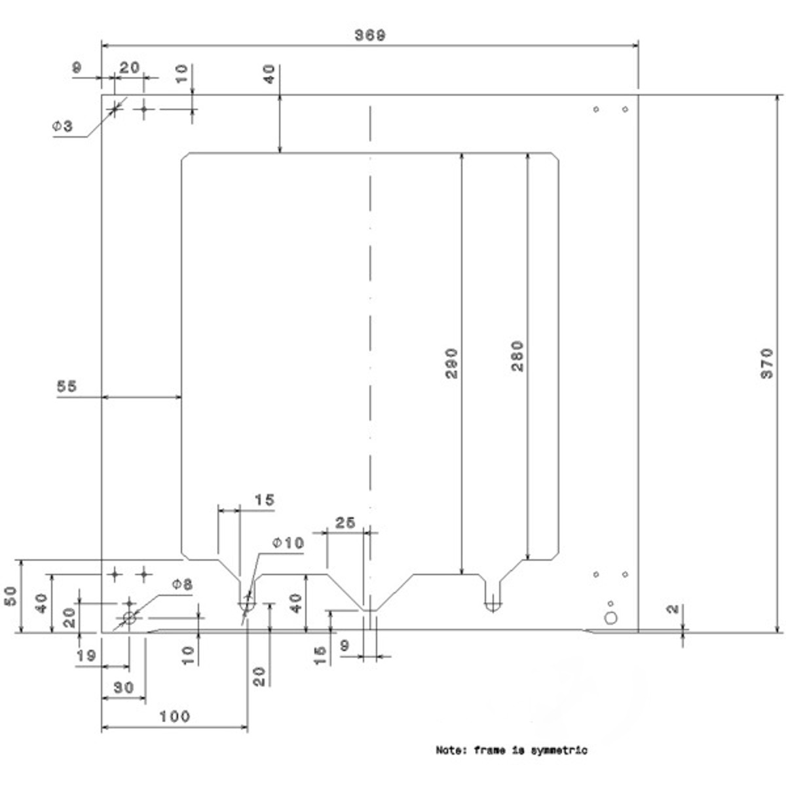

**III. CONCLUSION**

The above modification is done to improve rigidity and easily fabricate the machine. It also helps in reducing the maintenance cost and less down time.

**REFERENCES**

[1]. Joseph Prusa , “http://josefprusa.cz”.

[2]. Adrian Bowyer, “http://adrianbowyer.com/”.